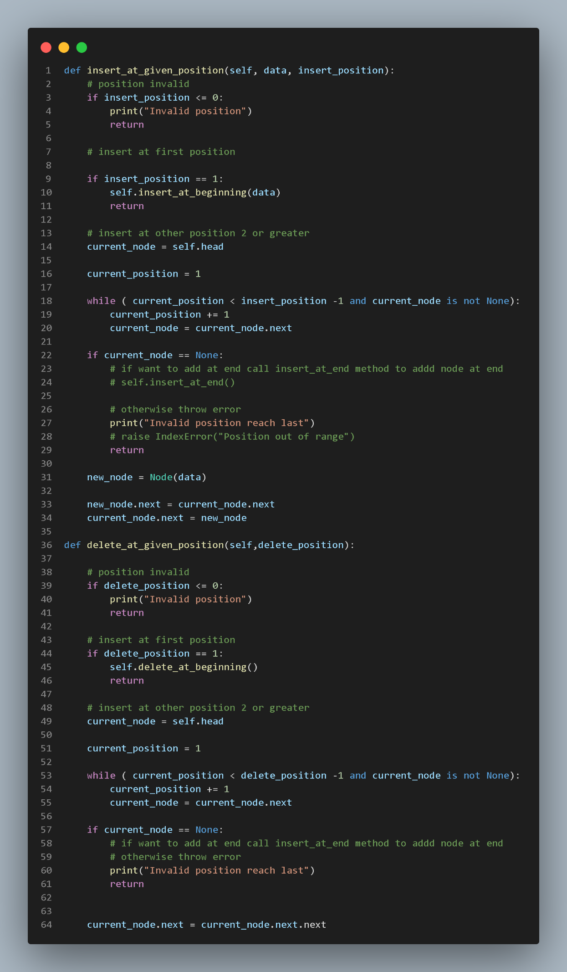insert_at_given_position and delete_at_given_position